**Create Node-RED Service**

|  |  |
| --- | --- |
| **Date** | 16st November 2022 |
| **Team ID** | PNT2022TMID45387 |
| **Project Name** | Gas Leakage Monitoring and Alerting  System |
| **Maximum Mark** | 4 marks |

**TEAM LEADER: ABDUL AZIZ M**

**TEAM MEMBER 1: KARTHICK PANDIYAN R**

**TEAM MEMBER 2: JEGAN J**

**TEAM MEMBER 3: AYYANAR S**

**Aim**:

To create a web application, create a Node-RED service.

# Steps to be followed

Step 1: Navigated to the App creation page and Entered project details and clicked on create

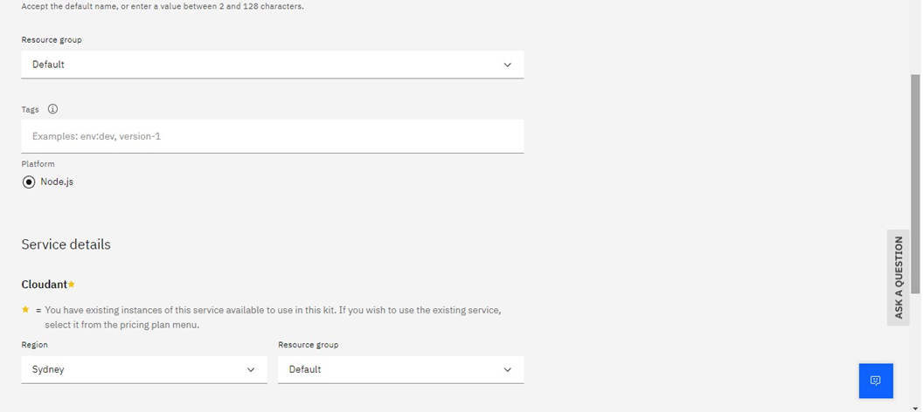

Step 2: Clicking on the “Deploy your App” Button and Setting up the environment and deploying the app.

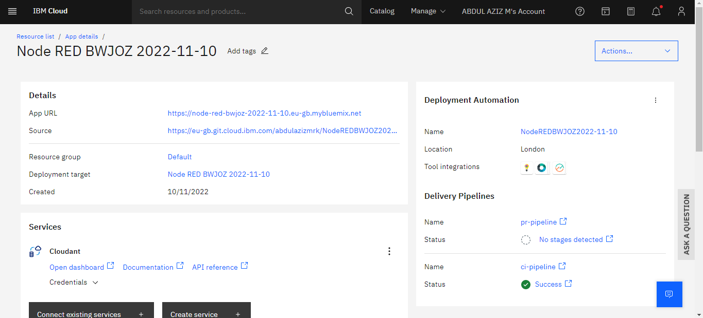

Step 3: Successfully deployed the app.

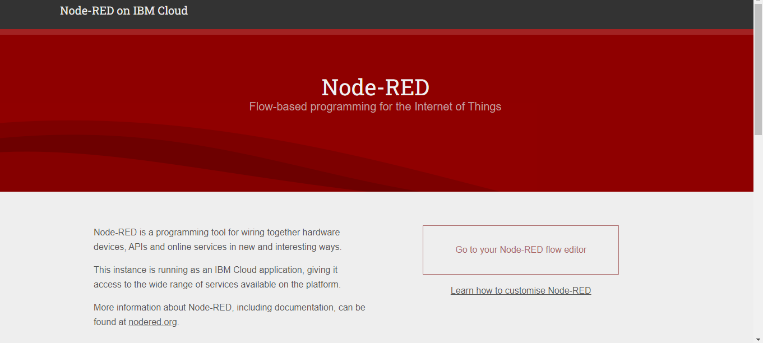

Step 4: Dragged and dropped components into the editor.

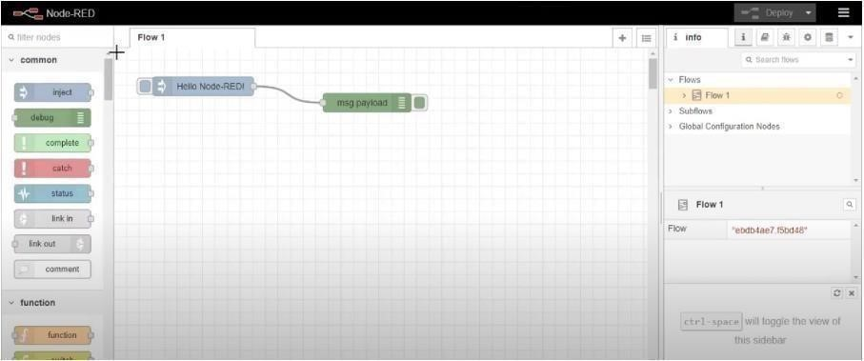

Step 5: Editing some values of the properties.

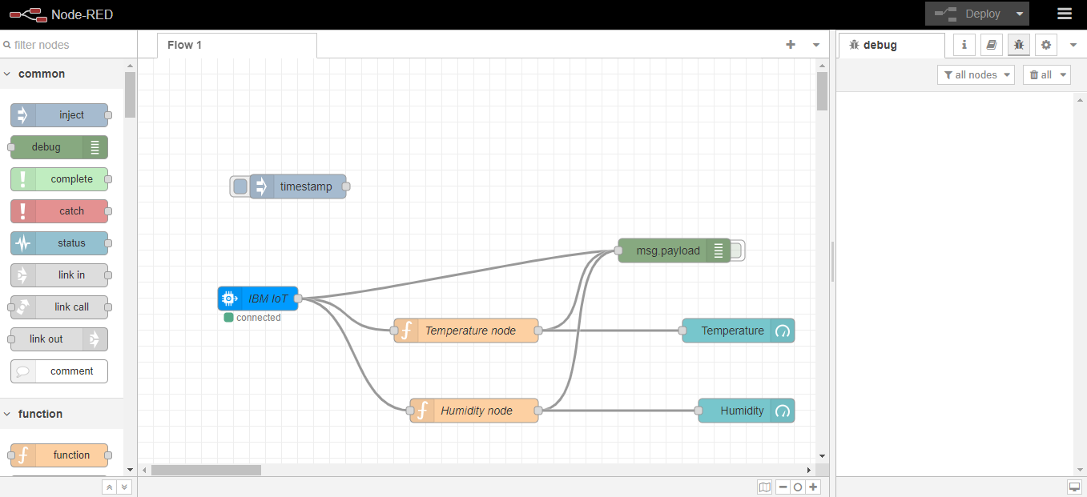

Step 6: Successfully deployed the app.

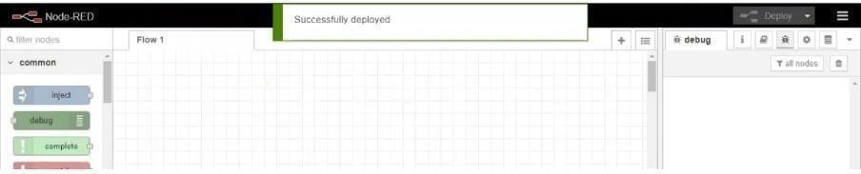

**Result:**

Successfully created a Node RED service on IBM Cloud.